Works Cited
Hodges, Miles. Ancient India. N.d. Photograph. N.p.
Kenoyer, J.M. Indus Valley Seal. N.d. Photograph. N.p.
Gallery, Barakat . Indus Pot. N.d. The Barakat Collection, Great Britan. Barakat Gallery. Web. 27 Jan. 2014.
Asia, South . Indus River Valley Map. 2011. Time Maps, Online. Indus River Valley Civilization. Web. 27 Jan. 2014.

Ryan Christensen
Period 1
Indus Civilization (3000-1500 BC)

How to Make Your Civilization Disappear
[Future Solutions Now]
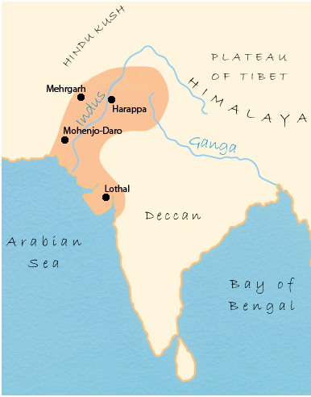

How to Have a Civilization
- You need to settle in an area that will provide possible ways that your civilization will disappear.
- You need a source of power, either have a person in a position of power or have a good force over people with military
- You need to have a giant population.
- You need to have a huge amount of food, too sustain a large population you need to have a good source of food.
- You need to have many cities. More cities can hold more people.
- You need to have a style of writing and inventions.
- You need to have a system of trade.

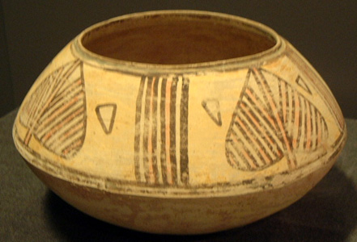

Make a Somewhat Lasting Civilization
Now that you have started your civilization, keep it going. A longer lasting civilization is a better one. If your civilization did not last very long, it will barely be remembered in the future (ex. Britannic Empire, Gallic Empire, Macedonic Empire).

Have Innovative Inventions
To keep your civilization remembered you must have great inventions (ex. Measurements, Scale, the Wheel, the Car, the Computer, etc.).
Before You Make Your Civilization Disappear, Consider How the Indus did it
The Indus people chose the perfect place to set up their civilization. To this day people still wonder how they disappeared. The Indus People did one of these ways below. The Indus people left different possibilities for how they disappeared.

All the Ways You Can Make Your Civilization Can Disappear
- Cause a natural disaster
- Salt all of your food
- Commit mass genocide
- Attack the Barbarians
- Have a river overflow
- Start your civilization before an ice age
- Start your civilization before the end of time
- Attack an advanced alien species
- Giant asteroid crashes into the Earth
- Global Warming
- Start the zombie apocalypse
- Start your civilization underwater (cough cough Atlantis cough cough)

Confuse Future People
After your disappearing act has been completed, you need to leave clues for people in the future to wonder how your civilization disappeared.

Make Sure to Leave Artifacts
